# Attempt 1:

## Actor Parameters

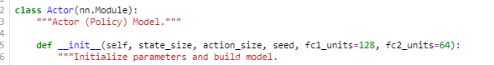

## Critic Parameters

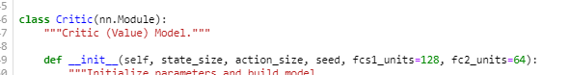

## Results

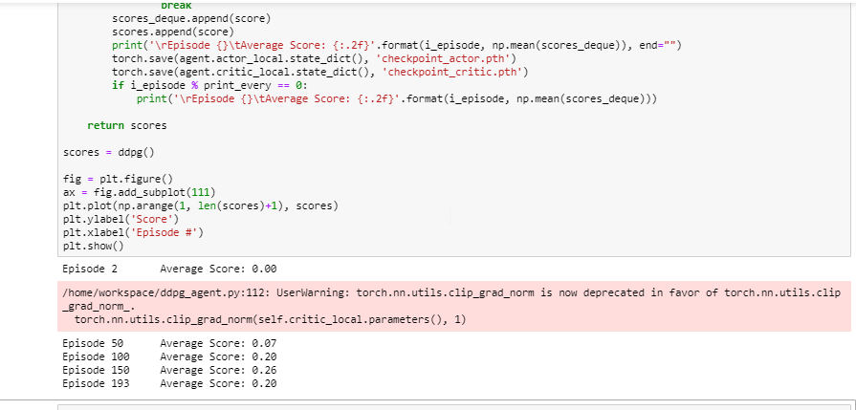

# Attempt 2 Batch Normalization:

# 

## Results

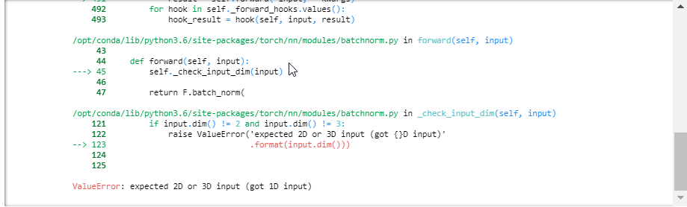

I do not understand why this BatchNorm1d creates this mistake. The input is a 33 by 1 vector??